Voice recording in Fifth Grade Spanish
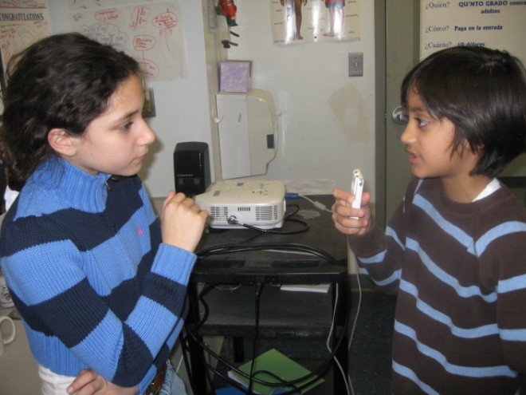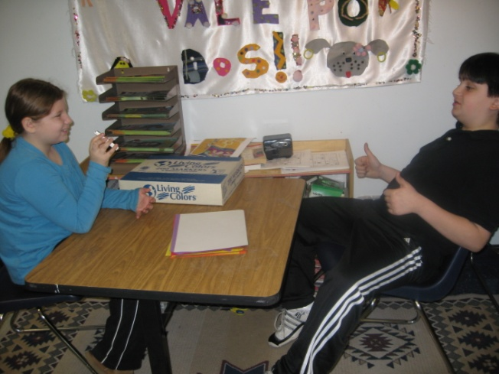
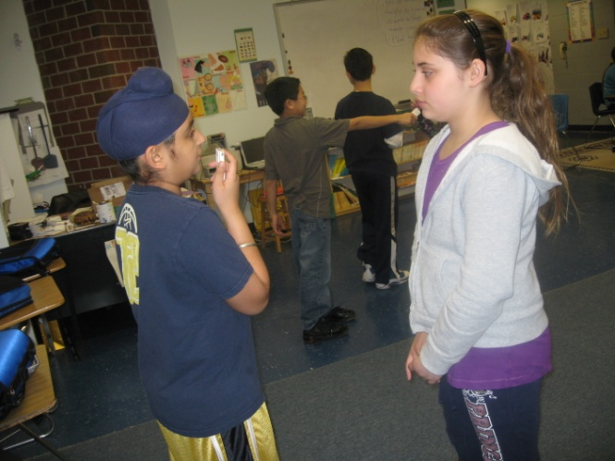
Students were to sustain an unscripted conversation in Spanish. They randomly chose a partner by picking a hidden name out of a basket. The conversation had to be at least three minutes long and without pauses. In order to do their best, students had to be able to respond well to questions and show interest in what their partner was saying. 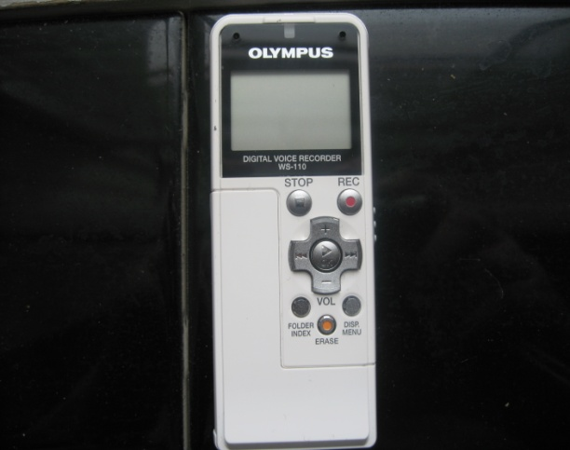 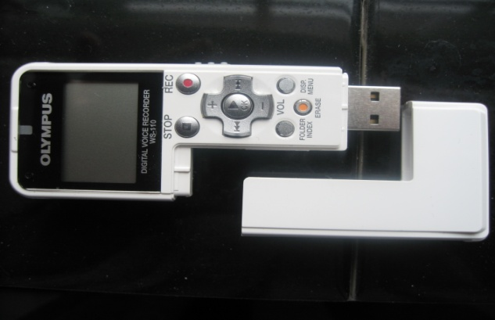
Having enough recorders for the class allows the pairs to record simultaneously so that students don’t have to wait their turn or be tethered to a computer for recording. They can move around the room or record in the hall. It can be instantly played back over speakers in class. The files can be easily downloaded onto a computer for sharing, e-mailing and posting.

